# Operating Systems Lab

**Lab#13**

**Task 1:**

Implement Banker’s algorithm by setting number of processes, maximum/allocated/need number of resources according to the following snapshot. Your output should display safe/unsafe state.

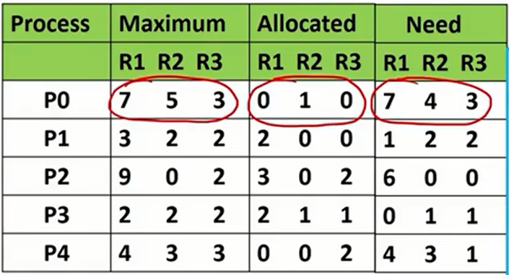

**Task 2:**

Implement producer consumer problem through wait () and signal ()  
operation in mutex semaphore value. User at the terminal has choice which  
process type that producer or consumer.